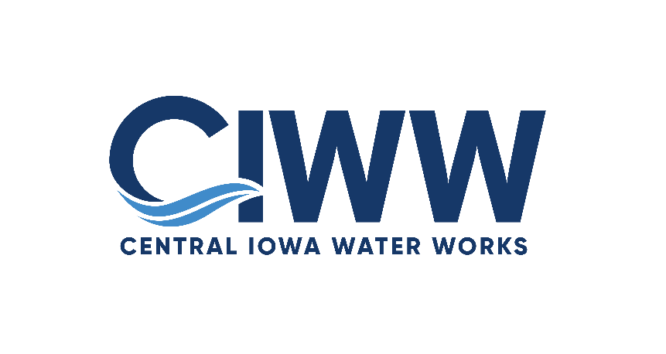
Temporary address:
2201 George Flagg Parkway
Des Moines, IA 50321
email: info@ciww.gov

Agenda
Executive Committee
Central Iowa Water Works
March 17, 2025
1:30 p.m.

Please join our meeting from your computer, tablet or smartphone.

Join Zoom Meeting
Meeting ID: 858 9401 8923
Passcode: 900139
United States:
+1 (309) 205-3325

Item 1: Call to Order
Item 2: Roll Call
Item 3: Review of Proposed Board Meeting Agenda
Item 4: Other Business
Adjournment

